SE Lab-7 (05-11-26)
  - Adithya, PES1UG24CS021, 5A

Initial Screenshots:
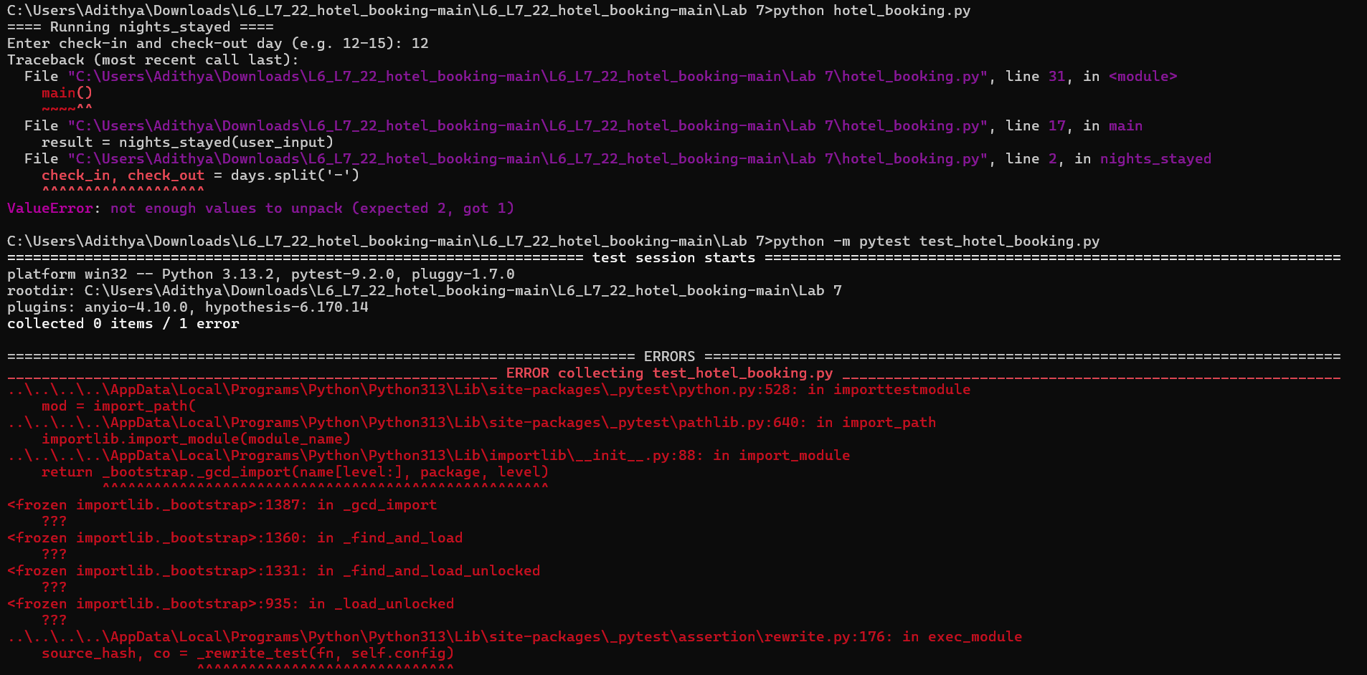
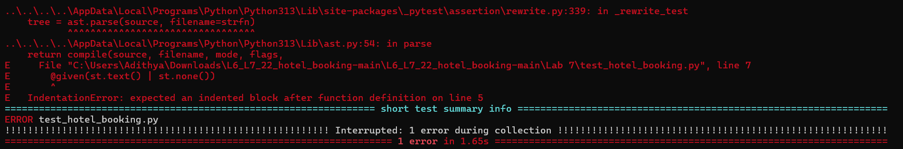

Final Code:

Hotel_booking.py:
def nights_stayed(days):
if not isinstance(days, str):
return None

parts = days.split("-")
if len(parts) != 2 or not all(part.strip().isdigit() for part in parts):
return None

check_in, check_out = (int(part.strip()) for part in parts)
if check_out < check_in:
return None
return check_out - check_in

def room_floor(room_code):
if not isinstance(room_code, str):
return None

parts = room_code.split("-")
if len(parts) != 2 or not parts[0].strip() or not parts[1].strip().isdigit():
return None
return int(parts[1].strip()[0])

def booking_label(names_csv):
if not isinstance(names_csv, str):
return None

names = [name.strip() for name in names_csv.split(",") if name.strip()]
if not names:
return None
lead = names[0]
return lead[0].upper() + lead[1:] + " +" + str(len(names) - 1)

def main():
print("==== Running nights_stayed ====")
user_input = input("Enter check-in and check-out day (e.g. 12-15): ")
result = nights_stayed(user_input)
print("Nights:", result)

print("\n==== Running room_floor ====")
user_input = input("Enter a room code (e.g. D-305): ")
result = room_floor(user_input)
print("Floor:", result)

print("\n==== Running booking_label ====")
user_input = input("Enter guest names as CSV (e.g. ravi, priya): ")
result = booking_label(user_input)
print("Booking Label:", result)

if __name__ == "__main__":
main()

test_hotel_booking.py:
from hypothesis import given, strategies as st
from hotel_booking import nights_stayed, room_floor, booking_label

@given(st.text() | st.none())
def test_nights_stayed_no_crash(s):
result = nights_stayed(s)
assert result is None or isinstance(result, int)

@given(st.text() | st.none())
def test_room_floor_no_crash(s):
result = room_floor(s)
assert result is None or isinstance(result, int)

@given(st.text() | st.none())
def test_booking_label_no_crash(s):
result = booking_label(s)
assert result is None or isinstance(result, str)

Final Screeshot:


